SAWA: African Youths training model

A brief history of the national service

National service is a system of either voluntary or compulsory government services often known as military service. It is a policy introduced by governments or states calling or making it mandatory for its young citizens after the age of 18, to serve their country for a specific period. It has been mainly designed for young men; however, few nations also include both genders in the implementation of the national service.

The history of National Service dates back to the Quinn Empire of China in 221 BC and the Egyptian Old kingdom (27th century BCE). However, following the French revolution, the first comprehensive nationwide system was instituted by Napoleon after he became emperor in 1803, then, between 1807 and 1813; Prussia introduced national service based on the principle of universal service which eventually became the model for the rest of Europe. In World War I, the British conscripted all young men on the day it declared war on Germany and continued to be mandatory in World War II until the war ended.
https://www.britannica.com/topic/conscription
https://www.parliament.uk/about/living-heritage/transformingsociety/private-lives/yourcountry/overview/conscriptionww2/

The goal of national service

Initially, the goal of the national service was mainly to secure and provide manpower during the time of war or crises. Usually, wars lead to more than expected losses and demand for more soldiers to replace the dead and the disabled. In modern history, that demand became crucial during World Wars I & II when hundreds of thousands if not millions were killed in the various battles fought. Conscription, compulsory military service, was introduced in Great Britain, Germany, France, Prussia, USSR and Japan. Eventually, many nations in Europe and other parts of the world have been continuing to use National Service mainly for national security and nation-building.

In the US conscription was introduced during the Civil war between the North and South. However, it was reintroduced as some form of a national program during the Roosevelt presidency. Since then, the national service evolved through various stages and programs within the military and non-military organizations, thereby contributing to the building of national cohesion and unity.

According to Krebs, although there are so many advantages or benefits of National Service, the three major benefits are: first, socialization of the participants: second, bringing together individuals of various ethnic backgrounds which create communications among them, and third, shaping the leadership of the society. In the national or military service, the participants do not just interact, but also learn how to truly communicate with each other which is of vital importance to national security. http://www.jstor.com/stable/4137450

Although many nations have adopted the policy of National Service, its implementation and the duration of the service differs according to the nation’s political and geopolitical conditions and its social values.

As mentioned earlier, nations in Europe that were involved in World War I & II, conscripted young men until the war ended. When the war was over, the program shifted to the volunteer program and selective recruitment.
Subsequently, while the national service shifted its form and goal in the major European countries, it expanded in other countries around the globe mainly to nations in conflict zones like the Middle East as in Israel which introduced the national service in1948. Several nations which got their independence after the second WW also adopted National Service.

Eritrea formally introduced The National Service in 1994. Essentially, it is the continuation of the training programs before independence. During the era of liberation struggle, all freedom fighters were involved not only in military training, but there were also regular sessions of political education of different levels and basic academic and vocational training. The main goals of the various training programs of the liberation movement were to raise the political consciousness of the fighters; acquisition of skills to serve in the workshops, health and education establishment units, ultimately contributing to the self and collective empowerment of the fighters. After independence, following the same principles, the national service training program was devised for the same purpose to produce a politically conscious, self-sufficient, confident, and patriotic youth, both female and male from all ethnic groups and religions. Ultimately, it creates national unity and social cohesion which is vital for national security and nation-building endeavors.

Nations which still have national service, the type and duration of the service:

Nations that have compulsory military service up to one year are Brazil, Estonia, France, Greece, Qatar, Sweden, and Turkey
Nations that require one year of military service include: Algeria, Bolivia, Colombia, Guatemala, Kazakhstan, Moldova, Mongolia, Paraguay, Russia, Taiwan, Tunisia, and Uzbekistan
Nations that require military service of no more than 18 months are: Azerbaijan, Belarus, Benin, Cambodia, Côte d'Ivoire, Cyprus, Egypt, Georgia, Kuwait, Laos, Morocco, and the United Arab Emirates.
Nations that require military service of longer than 18 months include Armenia, Angola, Central African Republic, Chad, Cuba, Eritrea, Equatorial Guinea, Guinea, Guinea-Bissau, Iran, Israel, North Korea, South Korea, Kyrgyzstan, Libya, Mali, Mauritania, Mozambique, Myanmar, Niger, Sao Tome and Principe, Senegal, Singapore, Somalia, Syria, Sudan, Tajikistan, Thailand, Turkmenistan, Togo, and Yemen.
Mostly, it is compulsory service for adult males. However, some nations have compulsory service for women. These countries are Armenia, Cape Verde, Chad, China, Eritrea, Israel, Norway, North Korea, and Sweden.
https://worldpopulationreview.com/country-rankings/countries-with-mandatory-military-service

All the nations mentioned above have had National Service that varies with time in its form and goals. The majority have used the national service program during the War and in the post-war era for nation-building and security. Few nations have also been using the national service to colonize and to protect the land they conquered. The specifics on how, why and for how long each country used national service or military service depends on its history, past or present.

When it comes to Eritrea, what makes its national service program different to be an object of blame and vilification? Why is Eritrea singled out and blamed for having a national service? Has there been any other nation that is demonized because of its national service policy? Why is Eritrea’s military service depicted by certain quarters as “ Slavery” while certain nations which in fact implemented national service to invade other nations not been questioned, let alone be demonized?

One of the major accusations of the national service of Eritrea, mostly by the Western governments and the so-called human rights organizations was for what they unjustly describe as “indefinite national service”. But why was the national service prolonged from a 2 years program? Except for the actual conspirators, several governments, non-governmental organizations, and the general public in Europe, North America and elsewhere accepted blindly the smear campaign without looking into the whole picture of the political and legal processes of the so called border conflict between Ethiopia and Eritrea.
Except for the few sell-outs, it has also been of some concern that some otherwise patriotic Eritrean citizens also seem to buy into the smear campaign without understanding the challenges Eritrea has been facing
Despite the individual challenges Eritreans, especially in the Diaspora, face in their day to day lives, they ought to be aware and/or educate themselves of the major challenges Eritrea has been facing since the invasion of the mercenary Woyanes. One of such key historical facts is the final and binding verdict of April 13/2003 to which Eritrea accepted and the Woyanes refused to implement. Moreover, it was the International Community or specifically, the guarantors for the implementation of the Algiers Treaty who did not fulfill their moral and legal responsibility to oblige the lawless Woyane to accept the verdict. Well, in the larger picture of the conspiracy against Eritrea, most of the so called guarantors were the enablers of the lawless Woyanes and they deliberately neglected it. Not only that, they also imposed an illegal sanction in 2009 and 2010 which was supposed to suffocate the Eritrean economy and stop its development endeavors. Faced with such unjust sanctions and hostilities while they kept neglecting the lawlessness of the Woyanes, Eritrea didn’t have any other choice except to prolong what was originally designed to be a nation-building program prolonged also to protect its NATIONAL SECURITY!!
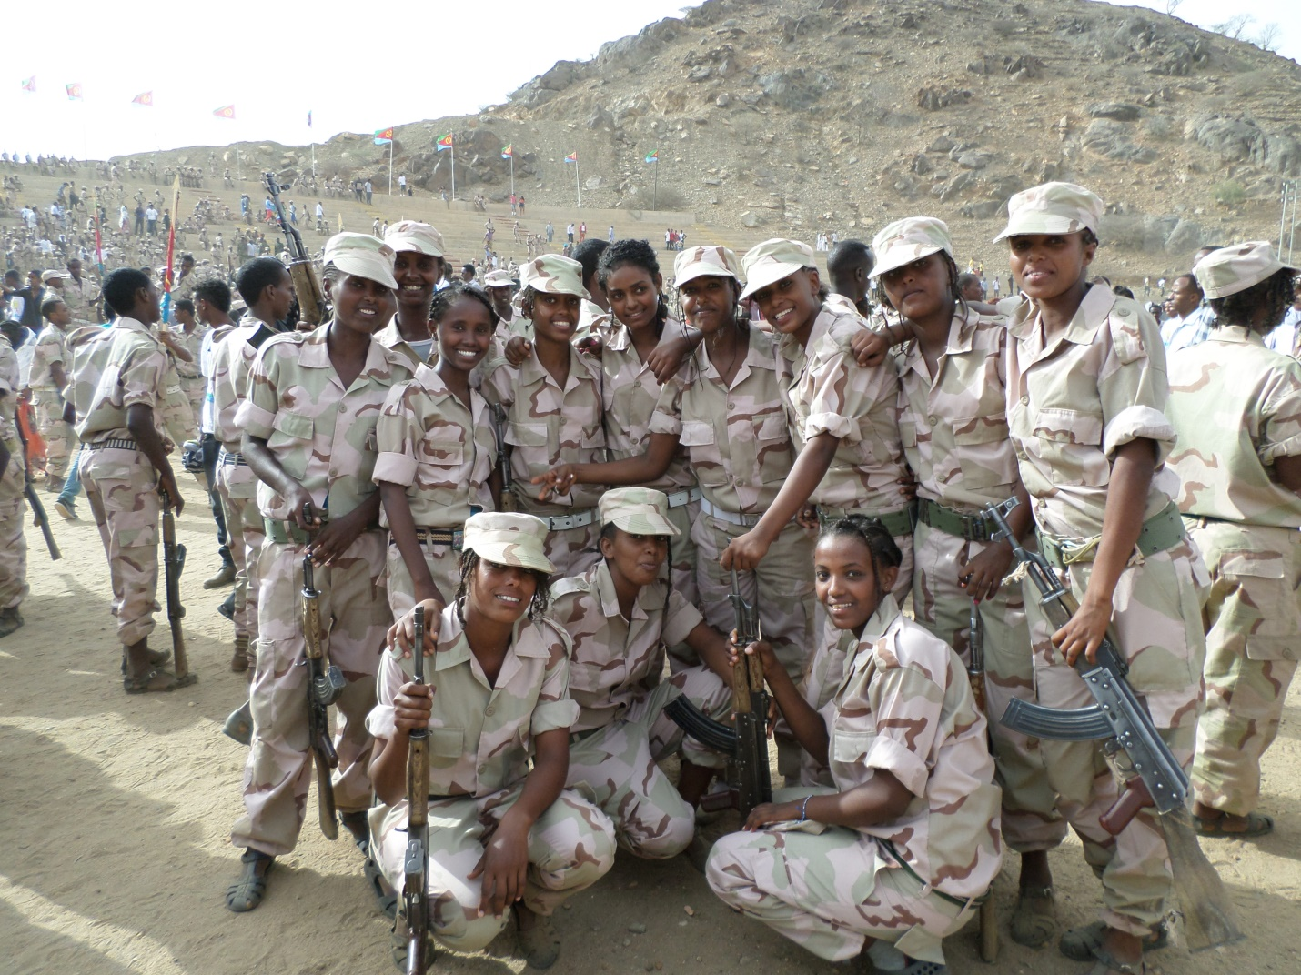

Over the last twenty years, Eritrean communities organized under what is known as MEKETE fought back against the injustices and smear campaigns against Eritrea and its leadership. Activists and few scholars, collectively or otherwise strongly advocated for justice. With regards to the nationals service program, it is worth sharing Sophie’s analysis which (http://www.madote.com/2015/11/eritrea-and-commission-of-inquiry.html) provided not only rich information that clearly described the challenges, but also compared the Eritrean nation-building program with the “U.S. Army Corps of Engineers” and makes one to read more about the history of national/military service and its contribution to nation building endeavors. https://www.usace.army.mil/About/History/Brief-History-of-the-Corps/

Those who are aware of media politics understand the smear campaign towards Eritrea in general and Sawa in particular. The fabricated and exaggerated reports by the so-called “Human Rights organizations”, “journalists” and few Eritreans sell-outs who pretend to act as advocates of Eritrean youth frequently associate the Eritrean national service with “slavery”. Ironically, it was one of the early top league sell-outs; a former member of the Eritrean leadership turned a slave of the Woyane mercenaries, who coined the term slavery in association with Sawa. Hundreds of fabricated narrations, reports of accusations have been compiled and propagated to smear Eritrea. On the contrary, only a little information can be found that discusses the real picture of Sawa out of the official Eritrean media outlets like Shabait and other few independent media outlets like Dehai, Madote, Eri Express and Tesfanews.

Following the successful reforms going on in Ethiopia and the restoration of peace and the developing close relationships between Eritrea and the Ethiopian leadership, the long misinformed Ethiopian public is slowly but surely getting to appreciate the real Eritrean values, challenges and accomplishments.

Recently, right after the 33rd round of graduation in Sawa, the Ethiopian “Mehal Meda” U- Tuber, Desu, took an excellent initiative presenting to his followers the graduation program under the title of the national service in Eritrea. https://www.youtube.com/watch?v=3lloU8AI3yA&t=5168s
The majority of the live comments were coming from Eritreans who trained in Sawa at different times starting from the 1st round. Sawa graduates from 1st, 2nd, 7th, 13th, 16th and one trainer in 2nd and 3rd round each shared their reflections and how the training positively impacted their lives and perspectives. The following are some highlights of their views.
Female 1st round: I consider Sawa as my mother. I value Sawa like my eyes “ Blien Ayney”
Female 9th round (who grew up in Ethiopia or Amiche): the existence of Sawa, guaranteed the existence of Eritrea.
Male 13th round: we learned about unity and also participated in development projects such as tree planting. Military training is only part of the program.
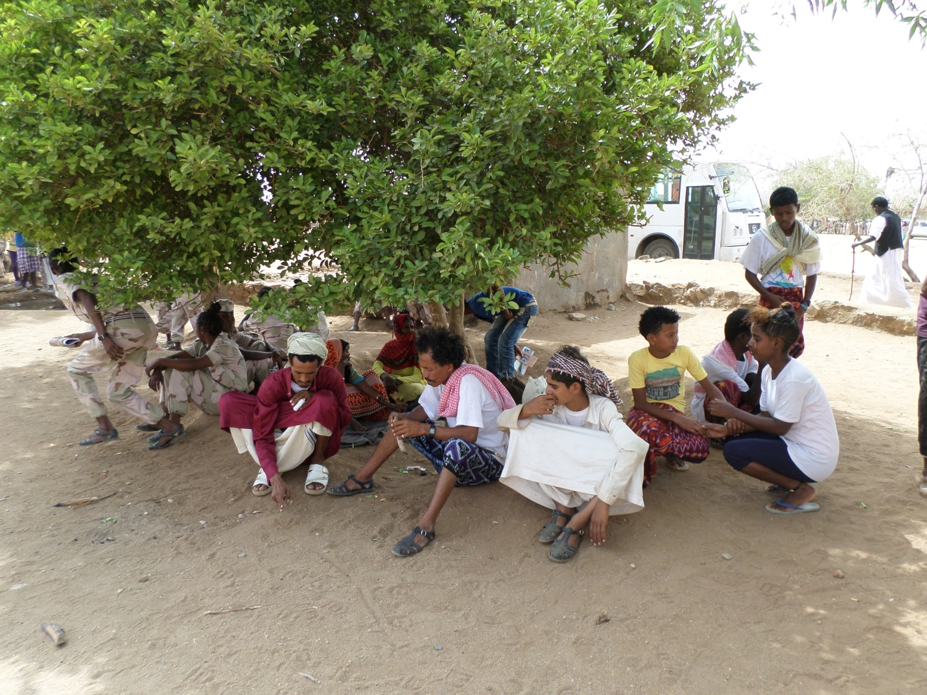
Male 16th round: We have never been instructed to hate Ethiopia or close to it. We learned about our national unity of all ethnic groups and religions.
Male 2nd and 3rd round trainer: Sawa makes you a strong person. Teaches discipline…tree planting has been going for the last 20 years. Sawa is the model of East Africa. He also mentioned Suzan Rice’s recent views regarding the implementation of compulsory national service in the US. Ironically, as a member of the Obama Administration, she was the one who officiated the illegal sanctions against Eritrea and tirelessly sweated in demonizing Sawa and the government of Eritrea. How shocking it is to hear Suzan Rice speak about the necessity of national service or is she sending a signal that she regrets the harm she and her close late Woyane chief did to Eritrea?

Besides the views of the trainees, there were a couple of parents who reside abroad also shared their personal and their children’s experiences. One is a father who sent his twin children to acquire a strong tie to their Eritrean heritage and identity. Her daughter is a doctor and the son is completing his studies. The other witness is a mother who resides in Sweden and used to participate in every graduation ceremony with her kids. She pointed out that there is a special program for high school graduates in Diaspora to get their diploma in Sawa. According to her, Sawa is a big pot where all youth from all ethnic groups, religious and social backgrounds learn unity and patriotism. With that, she and other male witnesses also recommended a youth training center modeled after Sawa to be built in Ethiopia.

During the early visits of Dr. Abyi to Eritrea there were rumors that the new Ethiopiapn leadership is looking at possibilities of introducing a youth training center in Ethiopia. Actually, his recent visit to SAWA solidifies those early rumors. Ethiopia which was ruled for more than two decades under a regime that intentionally built an ethnic based divisive political system has left the country with almost nonexistent social cohesion. SAWA type youth institution can address such challenges.
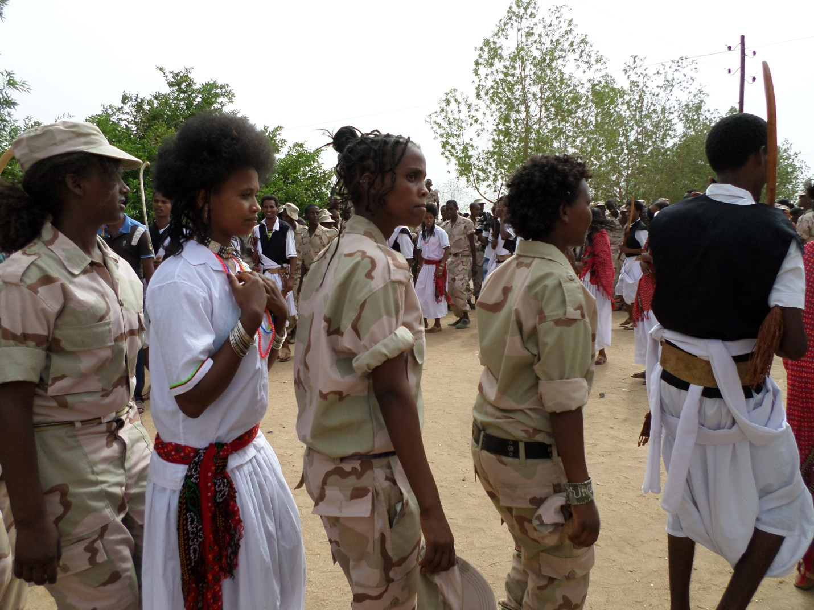

To conclude, taking the SAWA initiative to a wider scope, I persistently recommend that Sawa type youth institution should be established across Africa to produce strong, politically conscious, confident youth that creates a new collective perspective that decolonizes the colonized minds and to revive the vision of the early progressive African leaders like Kwame Nkrumah and Patrice Lumumba.

Bsrat Lul Tesfay
August 22, 2020

